Student’s Name: Kibet Brian
Admission Number: 190814
Lecturer’s Name: Mr. Talo Harrison
Course Unit: MST 8303 Penetration Testing, PT
Course Code: MST 8303
Lab - Using Meterpreter to backdoor Windows XP
Date: July 7th, 2025
Lab - Using Meterpreter to backdoor Windows XP
Windows XP IP address:
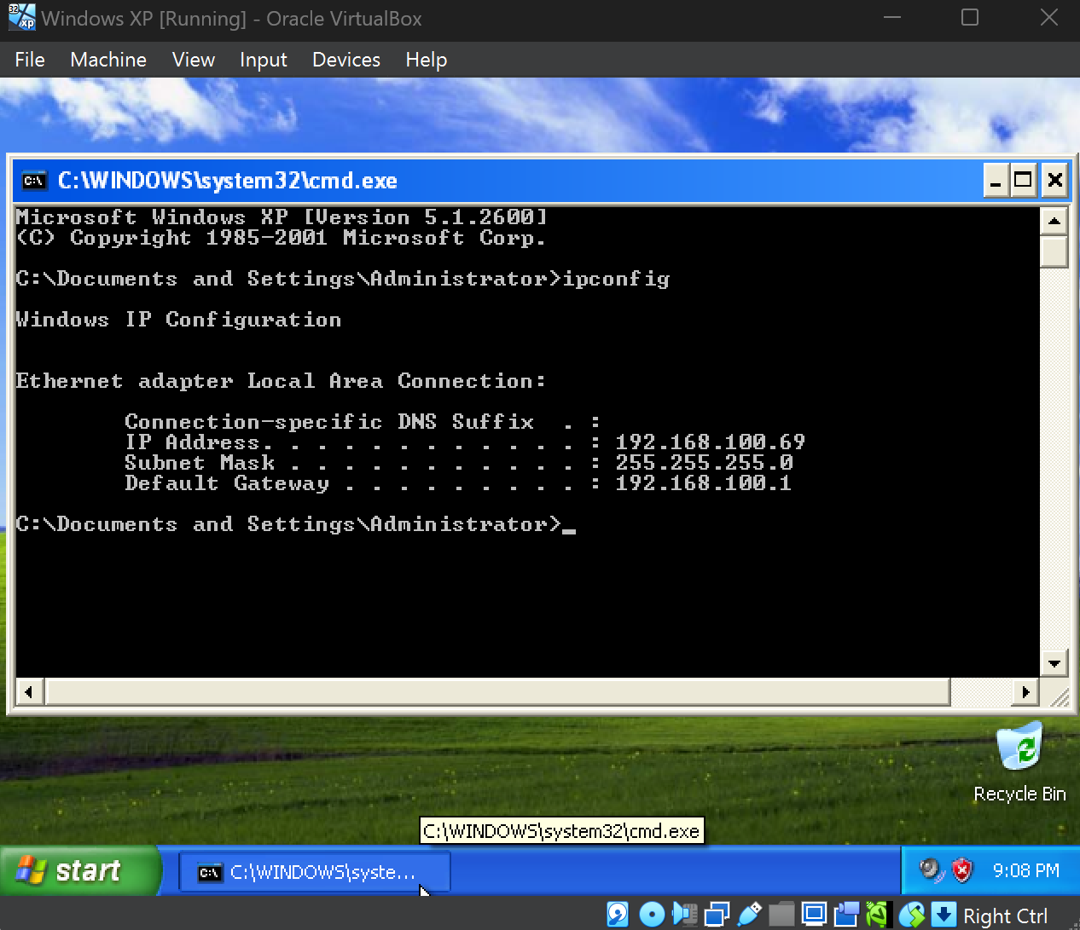

Confirming network range in Kali is same as that in Windows XP.
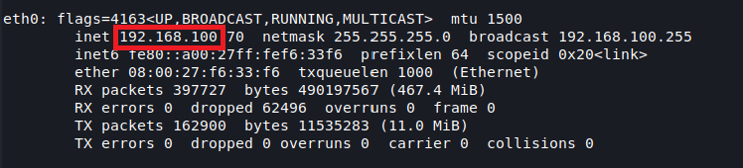
Pinging the Windows XP from Kali:
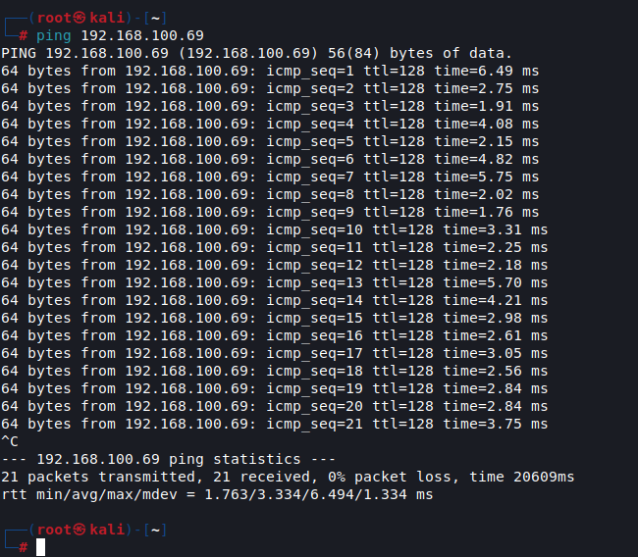

Allowing RDP access.
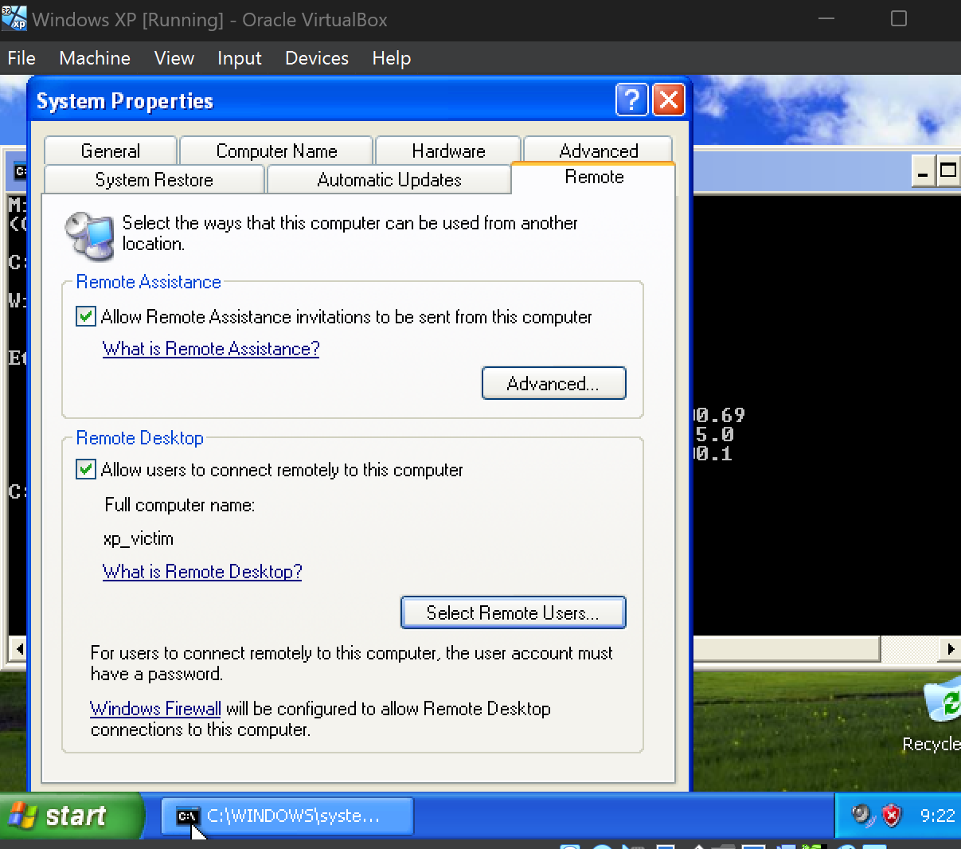
Nmap result.
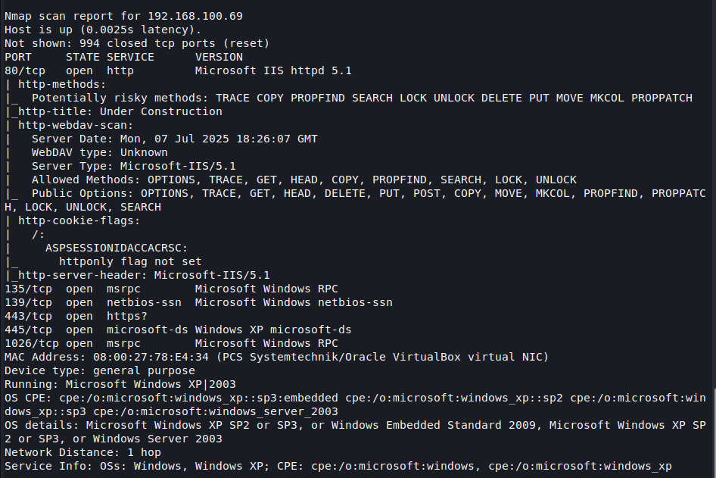

Launching meterpreter:
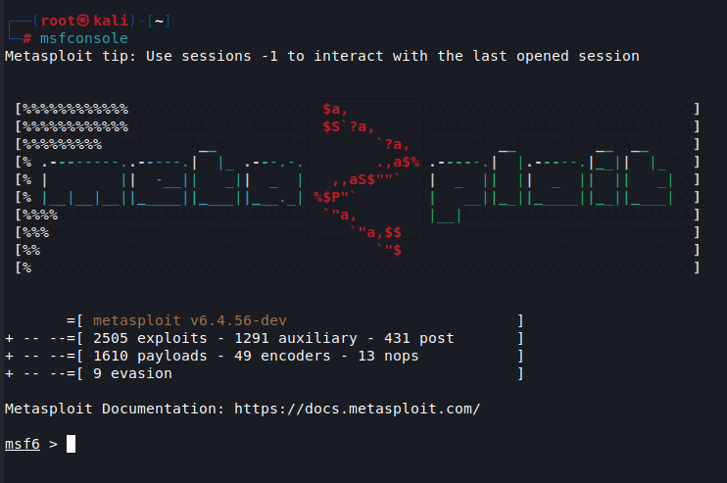
Setting IP address for RHOST.
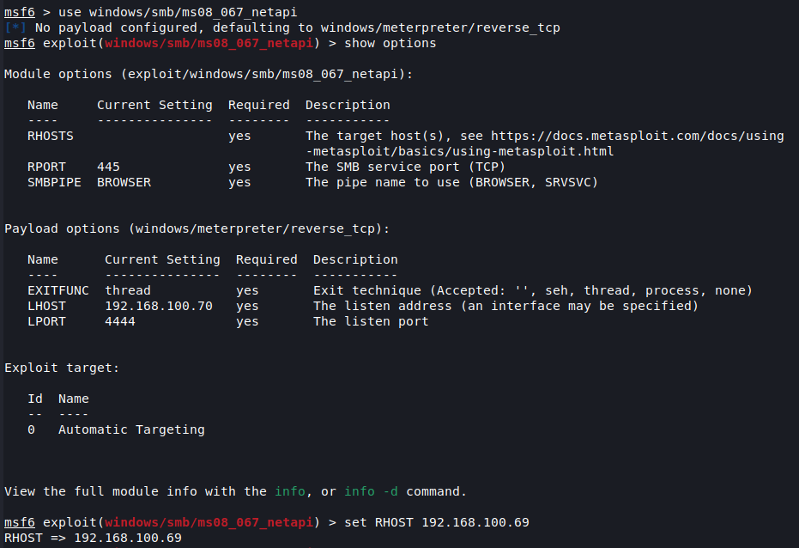

Launching payload using execute command.
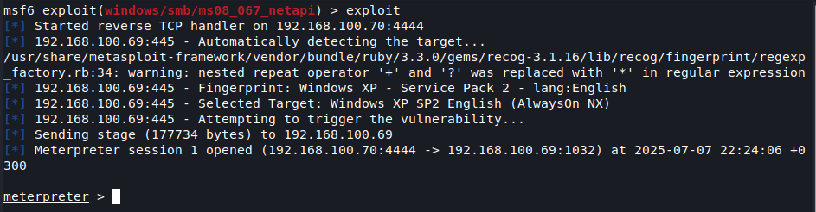

Checking to see if the machine has a firewall and if it is enabled.
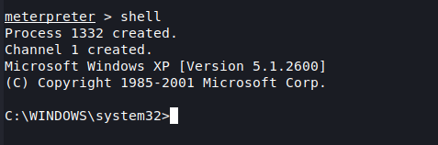
Checking the status of Windows firewall.
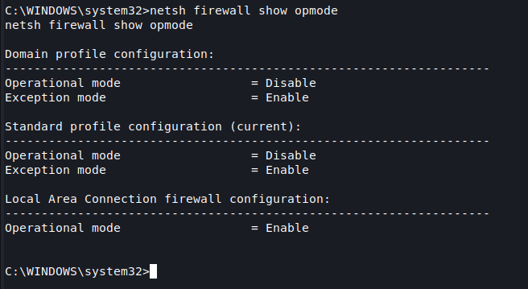

The command run getgui -h failed due to deprecation of getgui.
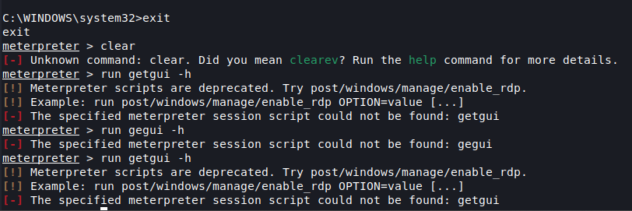

So instead, I did used this replacement.
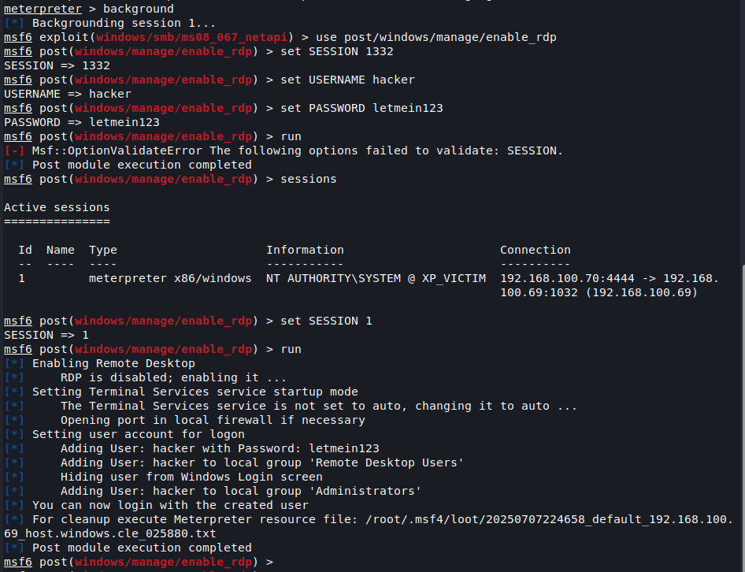

Using rdesktop
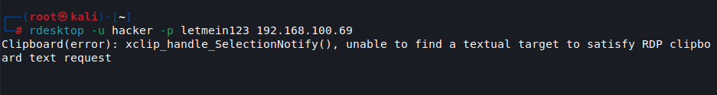

Logon message.
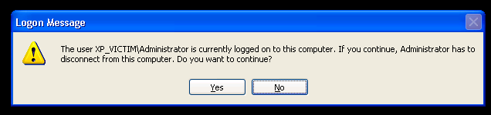

LOGGED IN!
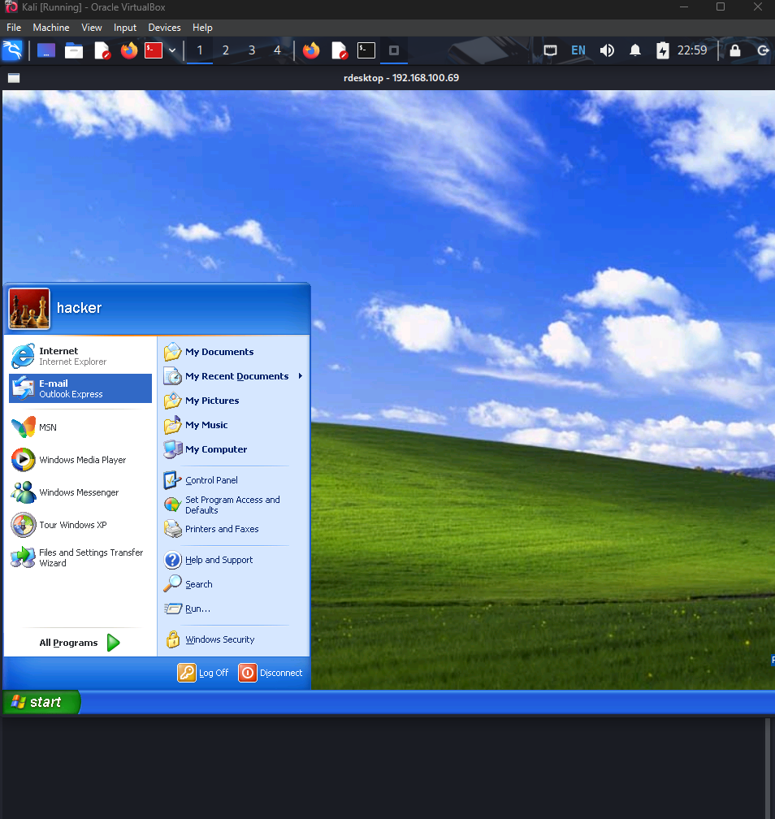

The command did not work.
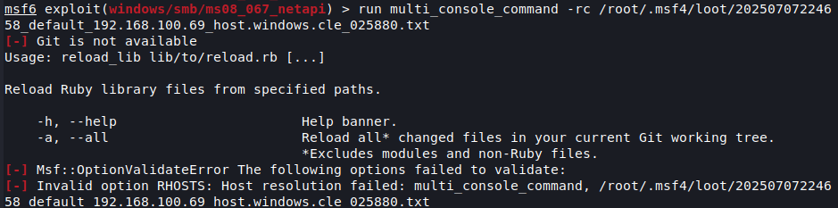

But the sessions are closed.
